LESSON A1-3: SECONDARY
TOPIC
A1
STORAGE, COMPRESSION &
SAAS [35]
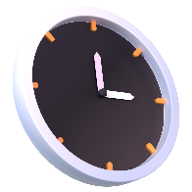
TIME TO COMPLETE: 1 HOUR
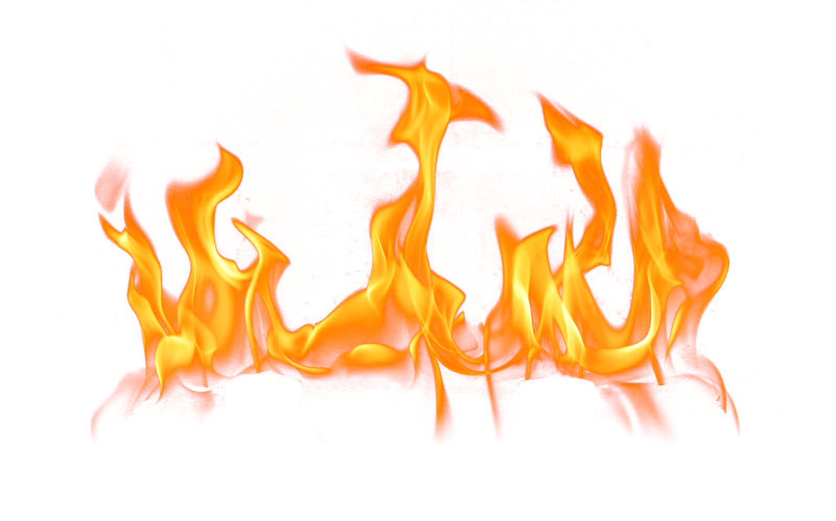

WARM UP:
WHAT YOU’LL NEED: PyCharm
Q1. Last lesson was all primary memory, none of which is permanent, modifiable storage.
(a) State what is meant by volatile memory. [1]

(b) From registers, cache, RAM and ROM, identify the one that is non-volatile. [1]

(c) Your PA A1-1 cache hit 40% of the time. A hit costs 1 ns and a miss costs 100 ns. Calculate the average memory access time. [1]

SECONDARY STORAGE: INSIDE THE MACHINE
Q2. Complete the table. [6]
Type | How the data is physically stored | A device you would find it in
HDD
SSD
eMMC
SECONDARY STORAGE: EXTERNAL
Q3. For each scenario, state the most appropriate external storage device and give one reason for your choice.
(a) A film crew must get 4 TB of raw footage to an editor in another city while on a small budget. [2]

(b) Four laptops in one house need to back up automatically to one shared device over Wi-Fi. [2]

COMPRESSION
Q4. (a) Distinguish between lossy and lossless compression. [2]

(b) State one file format that uses lossy compression, and one that uses lossless compression. [2]

Q5. Run-length encoding. Show the encoded string run through the algorithm. [5]
(a) Encode WWWBBBWWWBBBWWWBBB [2]

(b) Encode ABABABABABABABABAB [2]

(b) Decode 3A1B4C [1]

Q6. Outline what transform coding does to a file before any data is discarded. [2]

CLOUD COMPUTING
Q7. Complete the table. [3]
Service model | What the provider manages for you | One real example
SaaS
PaaS
IaaS

LAB
Q8. Describe two differences between an SSD and an HDD. [2]

Q9. A company must choose its own operating system, install its own database software, and patch both itself. Explain why IaaS suits this company better than SaaS. [3]

Q10. Spotify compresses its audio using a lossy method. Explain why this is acceptable for the audio, but would not be acceptable for Spotify’s payroll spreadsheet. [3]

